Experiment no-9
One-Stop Online Gadget Store
AIM:
To develop an online shopping website using HTML, CSS, and JavaScript to browse and search for electronic gadgets such as smartphones, laptops, and accessories. The system allows users to filter products, add items to the cart, place orders, and track their purchases.
Procedure:
- Create an HTML page to display electronic gadgets and prices.
- Apply CSS to design the product page.
- Use JavaScript to select products and calculate prices.
- Display the selected product and total amount.
- Run the program in a web browser.
Sample Code:
<!DOCTYPE html>
<html>
<body>
<h2>Electronic Gadgets Shopping</h2>
<select id="product">
<option value="15000">Smartphone - Rs.15000</option>
<option value="50000">Laptop - Rs.50000</option>
<option value="20000">Tablet - Rs.20000</option>
</select>
<button onclick="buy()">Buy Product</button>
<p id="result"></p>
<script>
function buy() {
let p = document.getElementById("product");
document.getElementById("result").innerHTML =
"Selected product: " + p.options[p.selectedIndex].text +
"<br>Total: Rs." + p.value;
}
</script>
</body>
</html>

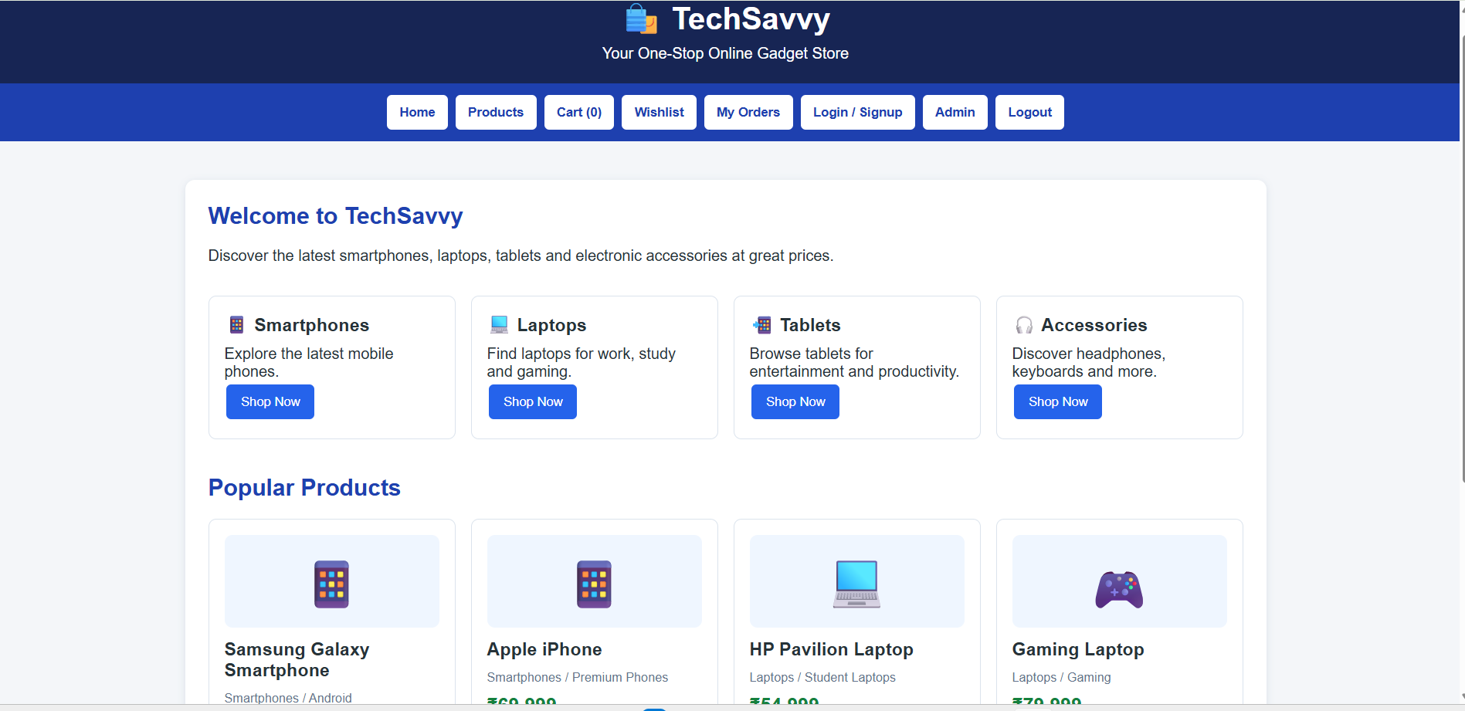

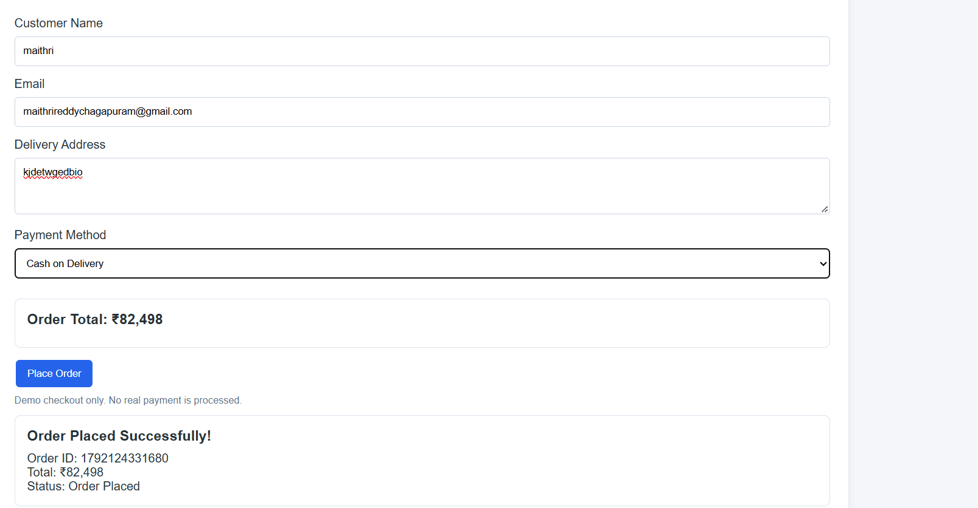
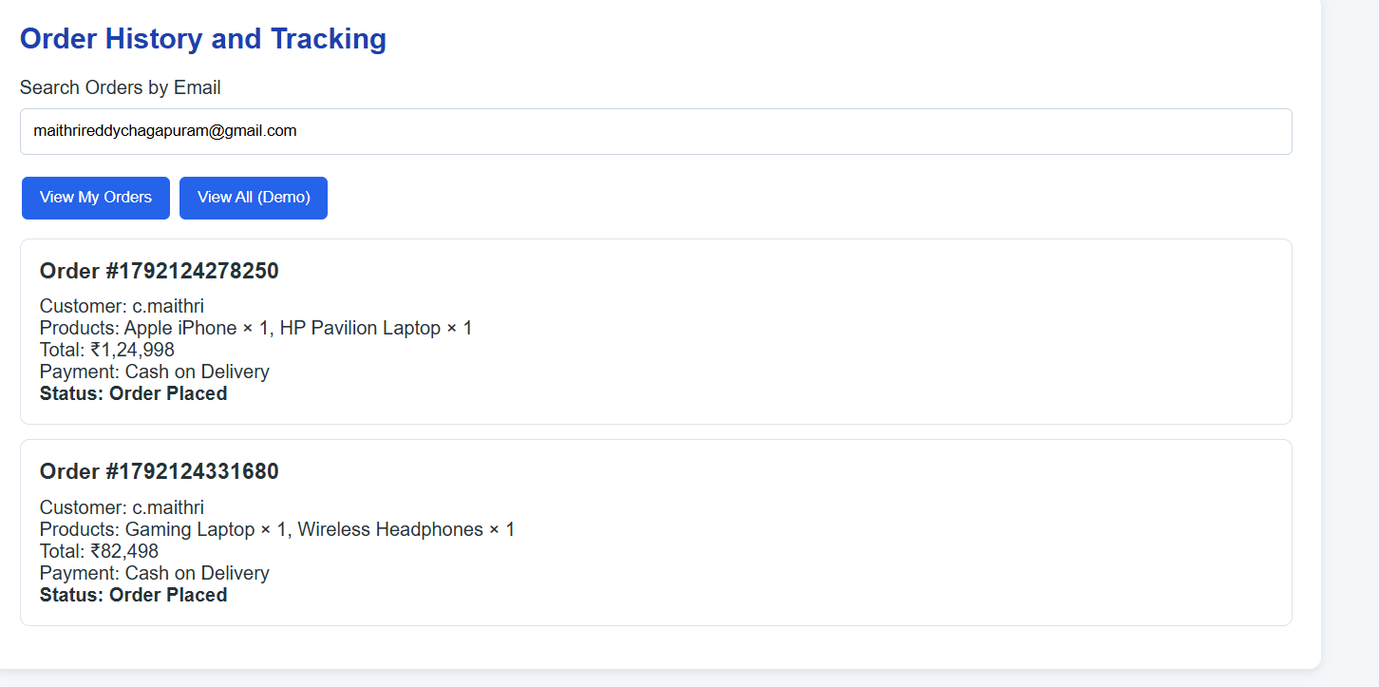
Result:
Thus, the electronic gadgets shopping website was developed successfully to select products, display prices, and show the selected product details.

